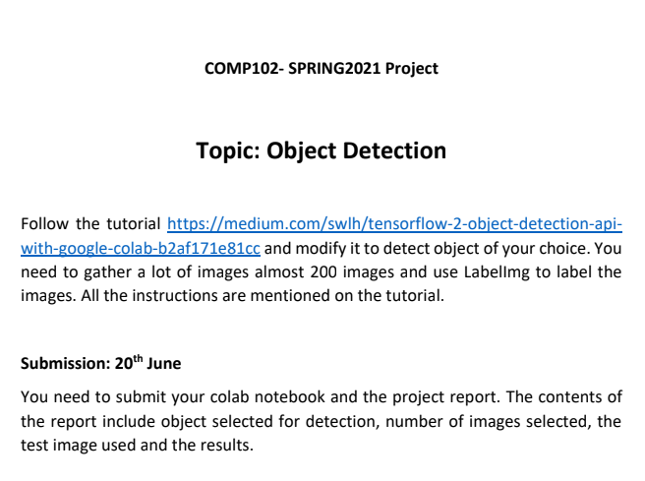

**Report:**

The colab notebook file named  
“Project_COMP102_(Abdullah_Mehtab_&_Faizan_Imtiaz_Cheema).ipynb”  
is attached along with this report.

**Contents of report:**

**Object selected for detection:**

The faces of my project partner, Faizan Imtiaz Cheema, and I, Abdullah Mehtab were the selected objects.

**Number of images selected:**

205 total images (80% for training, 20% for testing)

100 mine, Abdullah Mehtab

105 project partner’s, Faizan Imtiaz Cheema

Note: (.xml files not counted)

**Number of steps ran for the program:**

Total steps for training 10000:



Time escaped: 5 hours

**Test images/images used:**

I used 4 total images for test, 2 my project partner’s and 2 mine.

**Image results:**

Of my project partner Faizan Imtiaz Cheema:

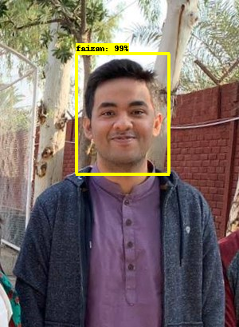

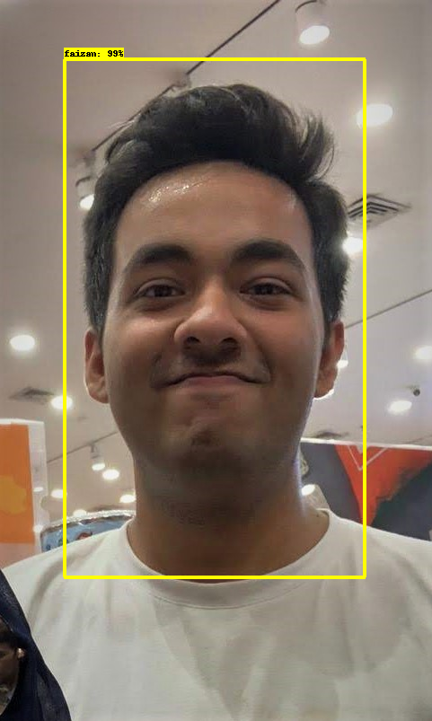

Of me, Abdullah Mehtab:

